CEBU INSTITUTE OF TECHNOLOGY
UNIVERSITY

COLLEGE OF COMPUTER STUDIES

Software Requirements Specifications
for
Software Project Document Manager Plus

Signature

Development Team:

ROSEMARIE L. CAPACIO
Project Lead/Developer

CHRISTIAN BACALSO
Web Designer/Developer

STEPHEN ARANDUQUE
Programmer Analyst

NICHOLATE ROSE VERAME
Tester/Documentation Officer

Change History

Date | Version | Description | Author
07/16/14 | v1.0 | First draft of the document | Rosemarie Capacio
07/25/14 | v1.1 | Added pictures for User interface and Use case 3(Faculty User Case) | Rosemarie Capacio, Christian Bacalso
10/5/14 | v1.2 | Finalization | Nicholate Rose Verame

Preface
This document contains the specific requirements of the software – Software Project Document Manager Plus. This is an existing software made by previous students enrolled in Software Project (CCS417) subject and was tested last summer. Some requirements were not met by the former developers so by this time, we are about to complete the system that is completely working with all its features specified.

Our team is determined to finish the whole system for the benefit of the future end-users. We will accomplish the system using software engineering principles. This software project is essential for our future career for this will serve as our foundation in creating software projects in the industry. We are on the stage of creating software requirements as part of our software development life cycle. Thus, as a result our team is indeed working on this document, in which, will serve as one of the legal papers pertinent to the software it is tasked to develop.

You will find in this document the categorized list of all the necessary specifications vital to the development of our software, resembling as its skeleton.

-SPDM⁺ Development Team

Table of Contents

Signature 2
Change History 3
Preface 4
Table of Contents 5
List of Figures 6
List of Tables 7
1. Introduction 8
1.1. Purpose 8
1.2. Scope 8
1.3. Definitions, Acronyms and Abbreviations 8
1.4. References 8
1.5. Overview 8
2. Overall Description 9
2.1. Product perspective 9
2.2. Product functions 9
2.3. User characteristics 9
2.4. Constraints 9
2.5. Assumptions and dependencies 9
3. Specific Requirements 10
3.1. External interface requirements 10
3.1.1. User interfaces 10
3.1.2. Hardware interfaces 10
3.1.3. Software interfaces 10
3.1.4. Communications interfaces 10
3.2. Functional requirements 10
3.2.1. Use case 1 10
3.2.2. Use case 2 10
3.3. Performance Requirements 10
3.4. Design constraints 10
3.5. Software system attributes 10
3.6. Other requirements 10
4. Appendixes 11
5. Index 12

List of Figures

[Figure 3.2.1] Admin User Case 14
[Figure 3.2.2] Editor User Case 15
[Figure 3.2.3] Faculty User Case 16

List of Tables
[Table 1.3] Definitions, Acronyms and Abbreviations 8
[Table 3.1.3] Software Interfaces 13

Introduction

Purpose

This document includes a detailed description of the Software Project Document Manager PlusError: Reference source not found. This describes the purpose and features of the system, the interfaces of the system, what the system will perform, and the constraints under which it must operate and how the system will react to external stimuli. This document is intended for both the stakeholders and the developers of the system and will be proposed to the College of Computer StudiesError: Reference source not found for its approval.

Scope

The primary goal is to increase project team efficiency by making the entire project cycle visible to all team members. Each team member is given their own login, allowing them to customize their view, report progress on their own projects, and monitor the progress of others. Most members find themselves to be more efficient in this environment, it allows people to identify problems before/as they arise, and it eliminates any question as to the current status of any outstanding tasks. It also provides a single access point for all project team information, eliminating lost memoranda or documents.

Definitions, Acronyms and Abbreviations
Term | Definition
Software Requirements Specification | A document that completely describes all of the functions of a proposed system and the constraints under which it must operate. For example, this document.
Stakeholder | Any person with an interest in the project who is not a developer.
User | The person, or persons, who operate or interact directly with the product. The user(s) and the  customer(s) are often not the same person(s).
[Table 1.3] Definitions, Acronyms and Abbreviations

References
ASTM E1340-96, Standard Guide for Rapid Prototyping of Computerized Systems.

IEEE Std 610.12-1990, IEEE Standard Glossary of Software Engineering Terminology.

IEEE Std 730-1998, IEEE Standard for Software Quality Assurance Plans.
IEEE Std 730.1-1995, IEEE Guide for Software Quality Assurance Planning.
IEEE Std 828-1998, IEEE Standard for Software ConÞguration Management Plans.

IEEE Std 982.1-1988, IEEE Standard Dictionary of Measures to Produce Reliable Software.
IEEE Std 982.2-1988, IEEE Guide for the Use of IEEE Standard Dictionary of Measures to Produce Reliable Software.
IEEE Std 1002-1987 (Reaff 1992), IEEE Standard Taxonomy for Software Engineering Standards.
IEEE Std 1012-1998, IEEE Standard for Software Verification and Validation.
IEEE Std 1012a-1998, IEEE Standard for Software Verification and Validation: Content Map to IEEE/EIA
12207.1-1997.

IEEE Std 1016-1998, IEEE Recommended Practice for Software Design Descriptions.

IEEE Std 1028-1997, IEEE Standard for Software Reviews.
IEEE Std 1042-1987 (Reaff 1993), IEEE Guide to Software Configuration Management.
IEEE P1058/D2.1, Draft Standard for Software Project Management Plans, dated 5 August 1998.
6
IEEE Std 1058a-1998, IEEE Standard for Software Project Management Plans: Content Map to IEEE/EIA
12207.1-1997.
7
IEEE Std 1074-1997, IEEE Standard for Developing Software Life Cycle Processes.
IEEE Std 1233, 1998 Edition, IEEE Guide for Developing System Requirements Specifications.

Overview

The next two chapters of this document will explain more about the software requirements specifications of this system. The second chapter provides the overall description of the project. It consists of the product perspective, functionsError: Reference source not found performed by the system, user characteristics, constraints and assumptionsError: Reference source not found. The third chapter concerns details of each of the system functions and actions in full for the software developers’ assistance. These two sections are cross-referenced by topic; to increase understanding by both groups involved.

Overall Description

Product perspective

Software Project Document Manager Plus is software used for project planning, scheduling, resource allocation and change management. It allows project managers (PMs), stakeholders and users to control costs and manage budgeting, quality management and documentation and also may be used as an administration system. Software Project Document Manager Plus is also used for collaboration and communication between project stakeholders.

Product functions
Although this software is used in a variety of ways, its main purpose is to facilitate the planning and tracking of project components, stakeholders and resources.
Software Project Document Manager Plus caters to the following primary functions:
- Project planning: To define a project schedule, a project manager (PM) may use the software to map project tasks and visually describe task interactions.
- Task management: Allows for the creation and assignment of tasks, deadlines and status reports.
- Document sharing and collaboration: Productivity is increased via a central document repository accessed by project stakeholders.
- Bug and error management: Project management software facilitates bug and error reporting, viewing, notifying and updating for stakeholders.

User characteristics
The users should be part of the College of Computer Studies and should have knowledge about software engineering and project management. These users could be teacher/instructor/adviser and the students with software projects.

2.4. Constraints
The options of the development of SPDM are limited by these constraints:
Parallel operation
The software runs with the parent system, CCS website.
Interfaces to other application
The software some features of the parent system.
Regulatory polices
    - all documentations of the project should be accomplished
    - all documents must be controlled by version and be updated after each change throughout the development.

Assumptions and dependencies
The software project will be planned following these assumptions:
- Project is a part of a larger project, CCS website.
- Conform to some features and constraints of the parent project, e.g. GUI, database.
- Code must be written in PHP language following the MVC framework.
- Project deadline must be met.

Specific Requirements

External interface requirements

3.1.1. User interfaces

The software is viewed through web-based user interface using browsers like Mozilla Firefox, Google Chrome and Microsoft Internet Explorer. The following images are the revised user interface design.

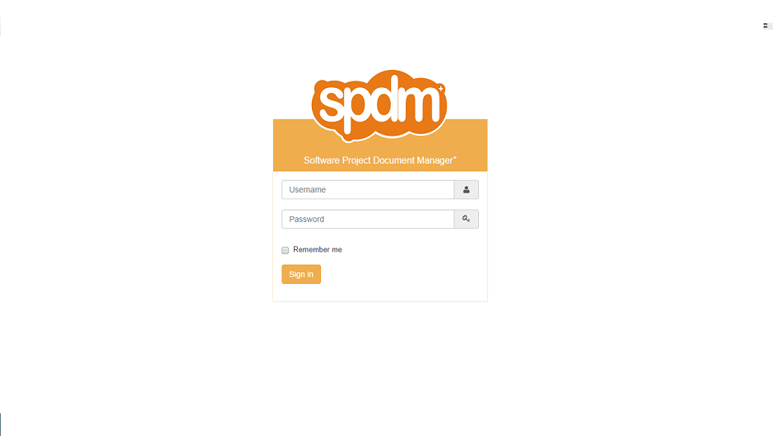
Log In Page

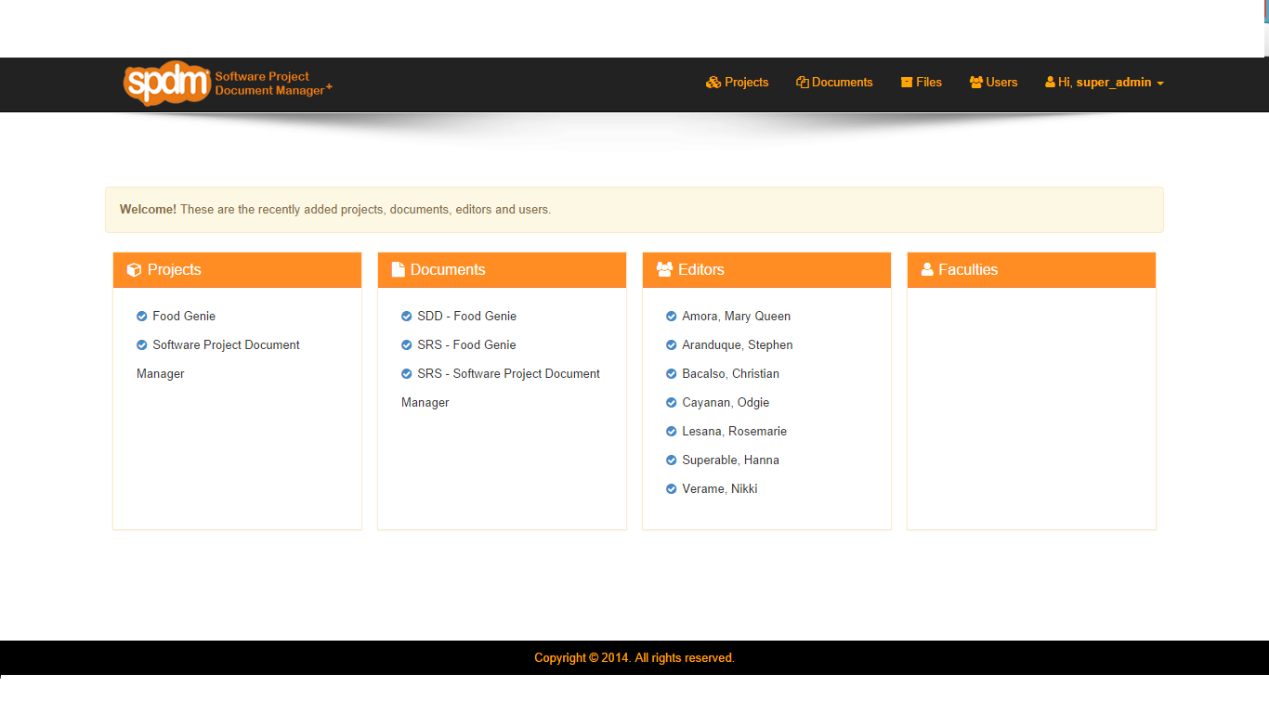
Home page

3.1.2. Hardware interfaces
- Database Administrator Workstation, which is the personal computer used by the database administrator to perform their tasks.
- User Client, which are the personal computers, personal digital assistants (PDAs), and smart phones used by users to communicate with each other and with the software over the Internet.
- Kiosk, accessible by all users and is positioned near the office of the College of Computer Studies.

3.1.3. Software interfaces
Software | Version | Description | Source
Notepad++ | 6.5.2 | a free (GNU) source code editor | Open (internet)
Microsoft Project 2007 | 2.0.2 | Project document generator | Open (internet)
XAMPP | 1.8.1 | - | Open (internet)
CKEditor | 3.6.2 | Embedded editing tool to be used by the users | Open (internet)
[Table 3.1.3] Software Interfaces

3.1.4. Communications interfaces
- Internet, which is the global network used for communication among employees, users, and the SPDM.
- Local Area Network

Functional requirements

3.2.1. Use case 1(Admin User Case)
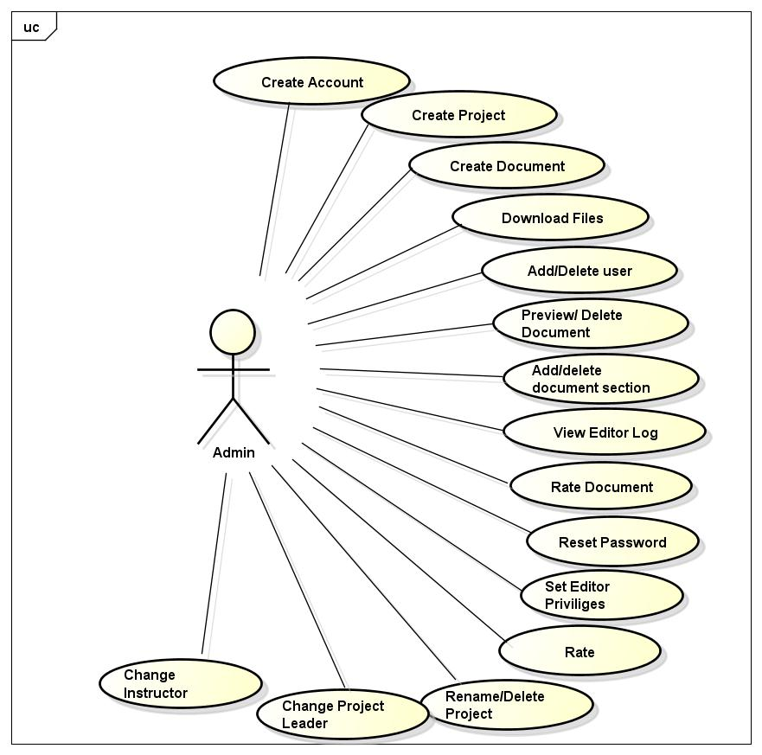
[Figure 3.2.1] Admin Use Case

3.2.2. Use case 2(Editor Use Case)
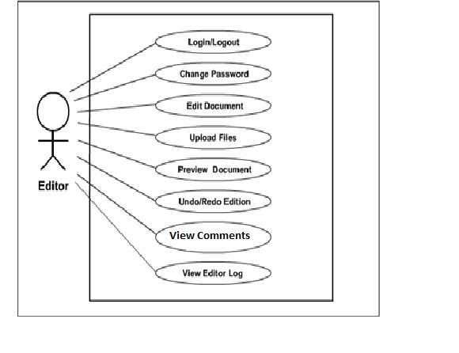
[Figure 3.2.2] Editor Use Case

3.2.3. Use case 3(Faculty Use Case)
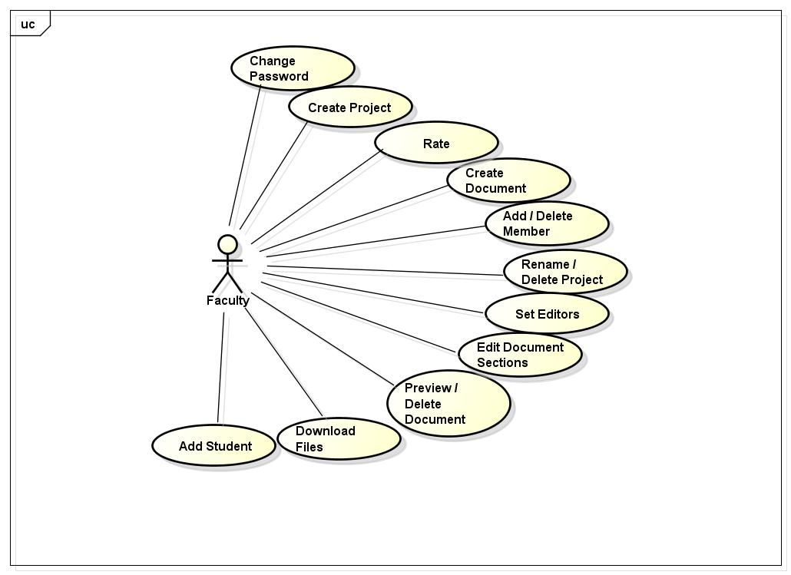
[Table 3.2.3] Faculty Use Case

Performance Requirements
- Static numerical requirements:
  - Being a web-based application, the SPDM supports unlimited number of terminals and simultaneous users. The data that is passed by the users when editing are mostly strings, except for the uploaded files of the users, which are all in an unlimited amount.
- Dynamic numerical requirements:
  - User- and admin-initiated operations are processed in less than 2 seconds.
  - Database-related operations processing, such as data saving, may cost more than 2 seconds depending on the amount of data.
  - Data upload process time also depends on the amount of data uploaded.

3.4. Design constraints
- UI constraints
  - UI design must conform to the main design of the parent system, CCS Website, which let the color orange of CCS dominates
  - Font is Arial; 12pt for main content, 16pt for headings
  - Header and footer background color is black
  - Background color of the body is white.
- Data naming
  - All classes are name by how its function.

3.5. Software system attributes
Availability
The software is always accessible via the CCS Website provided that it is enabled by the CCS department for access.
Security
Login is emphasized on the software, though a user is already logged on the CCS website, requiring the same account/user name but with different password.
The database is maintained by the parent system. The data passed by the editor-users are provided with back-up for document edition recovery.

3.6. Other requirements

Appendixes

Index

